Netlify automated build….

Console settings

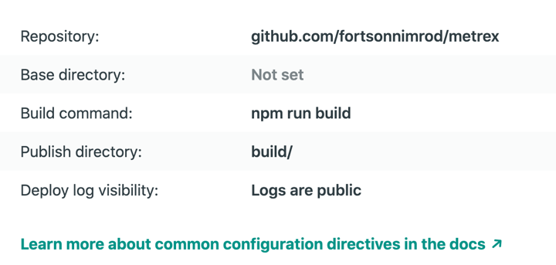

I did put in env variables:

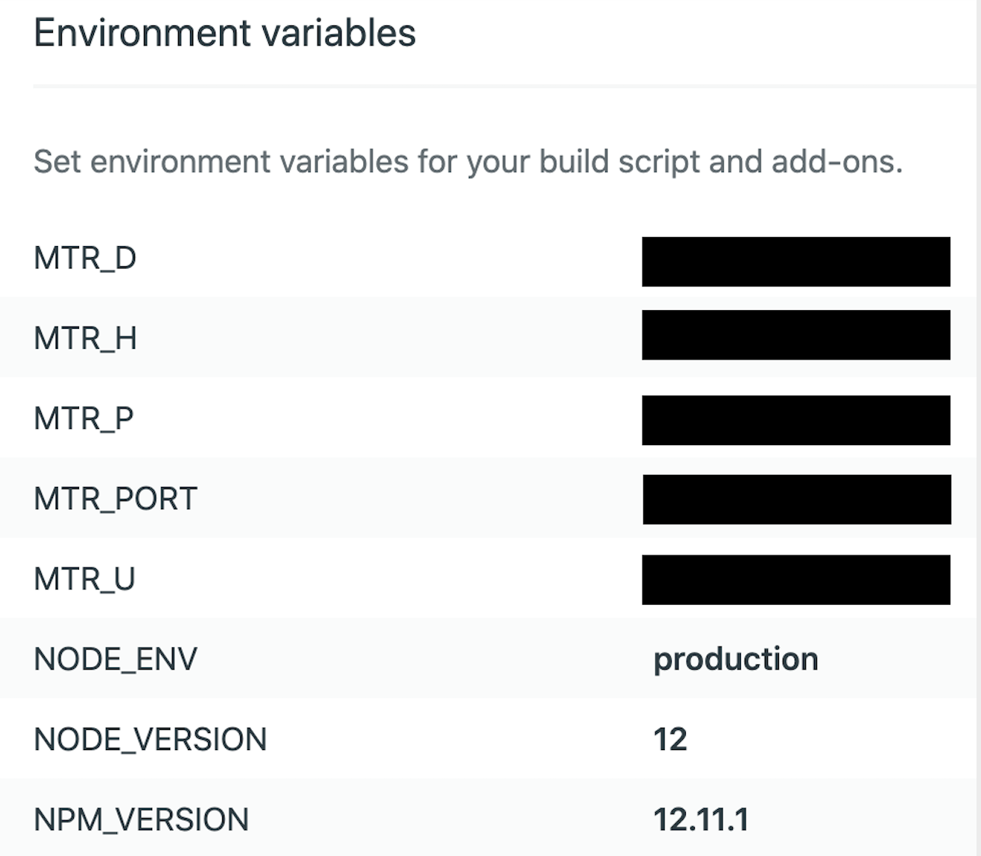

Build Logs:

9:11:50 PM: Build ready to start

9:11:54 PM: build-image version: 2dbd444fcdce00cf06325060a8238d5ae3e86774

9:11:54 PM: build-image tag: v3.3.7

9:11:54 PM: buildbot version: 93ff258b60dcc6c2c8bb9cfe1ece15d7b4f24193

9:11:54 PM: Fetching cached dependencies

9:11:54 PM: Starting to download cache of 254.9KB

9:11:54 PM: Finished downloading cache in 63.443521ms

9:11:54 PM: Starting to extract cache

9:11:54 PM: Failed to fetch cache, continuing with build

9:11:54 PM: Starting to prepare the repo for build

9:11:55 PM: No cached dependencies found. Cloning fresh repo

9:11:55 PM: git clone https://github.com/fortsonnimrod/metrex

9:11:55 PM: Preparing Git Reference refs/heads/master

9:11:55 PM: Starting build script

9:11:55 PM: Installing dependencies

9:11:57 PM: Downloading and installing node v12.16.2...

9:11:57 PM: Downloading https://nodejs.org/dist/v12.16.2/node-v12.16.2-linux-x64.tar.xz...

9:11:57 PM:

####################

9:11:57 PM: 28.0%

9:11:57 PM:

######################################################################## 100.0%

9:11:57 PM: Computing checksum with sha256sum

9:11:57 PM: Checksums matched!

9:12:00 PM: Now using node v12.16.2 (npm v6.14.4)

9:12:00 PM: Attempting ruby version 2.6.2, read from environment

9:12:01 PM: Using ruby version 2.6.2

9:12:01 PM: Using PHP version 5.6

9:12:01 PM: Started restoring cached node modules

9:12:01 PM: Finished restoring cached node modules

9:12:02 PM: Found npm version (6.14.4) that doesn't match expected (12.11.1)

9:12:02 PM: Installing npm at version 12.11.1

9:12:02 PM: npm

9:12:02 PM: ERR!

9:12:02 PM: code ETARGET

9:12:02 PM: npm ERR! notarget No matching version found for npm@12.11.1.

9:12:02 PM: npm ERR! notarget In most cases you or one of your dependencies are requesting

9:12:03 PM: failed during stage 'building site': Build script returned non-zero exit code: 1

9:12:02 PM: npm ERR! notarget a package version that doesn't exist.

9:12:02 PM: npm ERR!

9:12:02 PM: A complete log of this run can be found in:

9:12:03 PM: Shutting down logging, 5 messages pending